Pillow packing machine (OPP) ZRS-450X
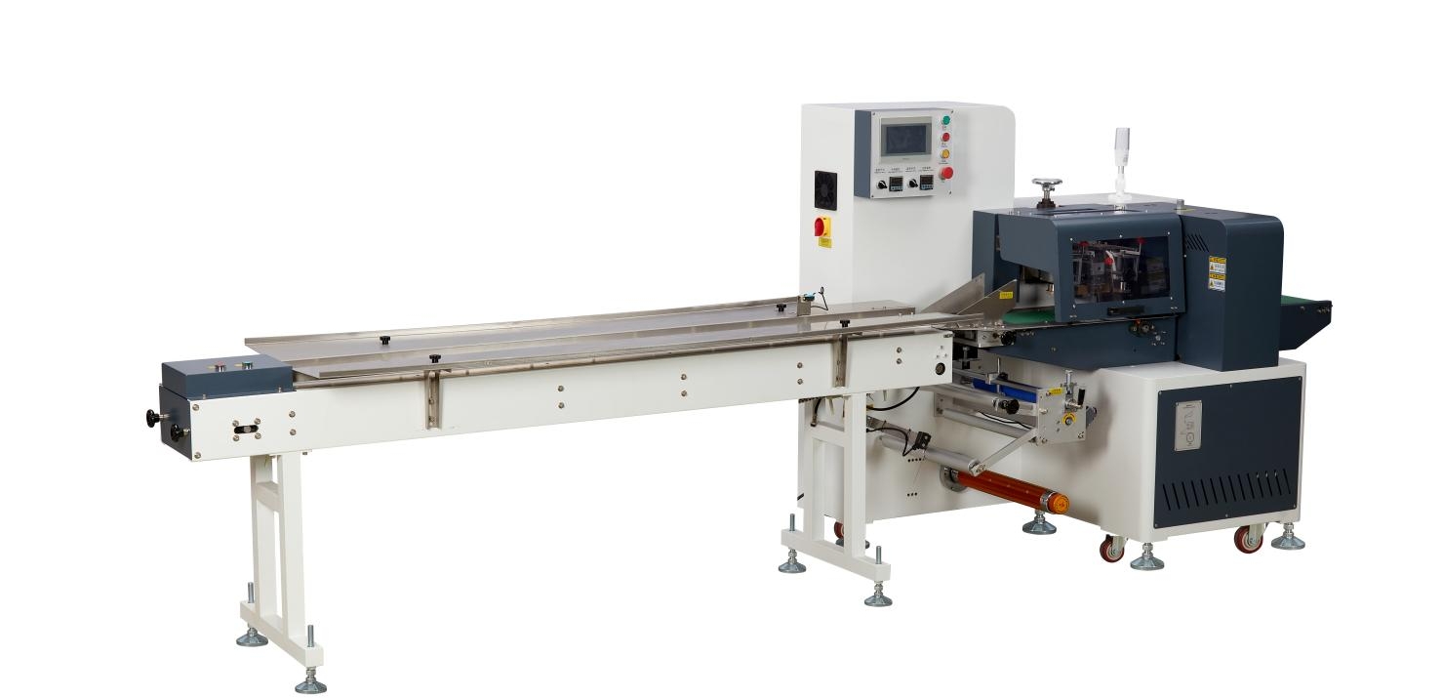
Equipment Layout：
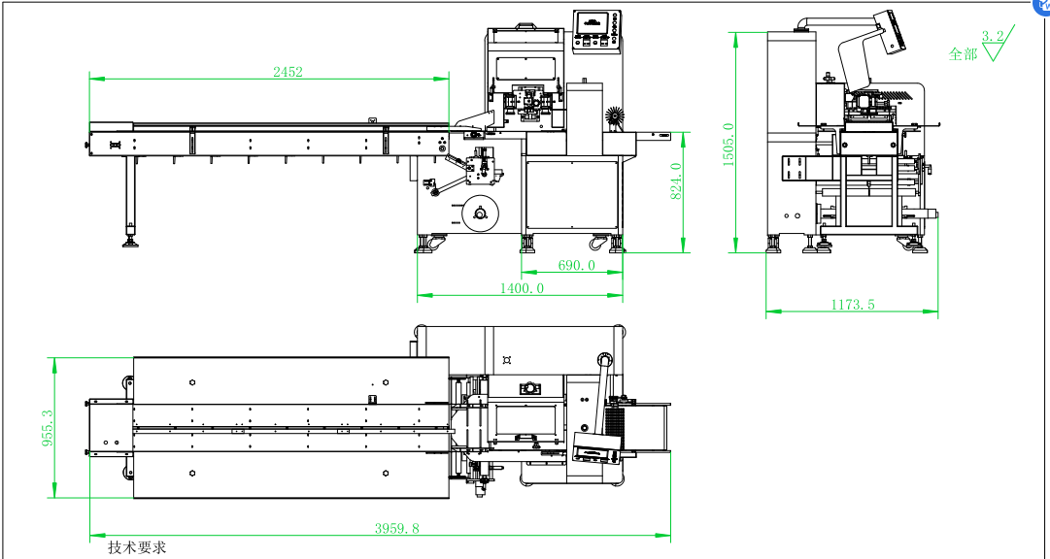
Basic Use：
Widely used in pillow packaging in adhesive products, daily chemicals, printing, food, hardware, toys and other industries.

Product characteristics：
- PC system control, can only run, the bag length can be set and cut immediately, in one step, saving time and film.
- Automatic shutdown without film, standby without material, air defense bag.
- Anti-stick cutter, made of high-speed die steel, surface Teflon treatment, anti-sticking of packaging film, to enhance the service life of the cutter
- Color touch screen control, convenient and quick parameter setting, can store 49 packaging parameters.
- Fault self-diagnosis function, the fault display is clear at a glance, and the fault can be quickly eliminated.
- High-sensitivity photoelectric eye color mark tracking, digital input of sealing and cutting position, more accurate sealing and cutting position, and more exquisite color film packaging.
- The transmission system is simple, the work is more reliable, and the maintenance is more convenient.
- Anti-miscut protection. If the setting is wrong, the sealing knife will automatically turn over when the product is cut, protecting the knife holder and the product, and making it safer.

Main Technical Parameters：
Model | ZRS-450X
Pack size | w（40-150MM）*H（5-65MM）
Speed | 80-150PCS/M
Power | 1P 220V 50/60HZ 4.4KW
Machine size | 4500*1200*1680
Packing kind | （BOPP, double-adhesive, foam tape）
Net Weight | 500KG

Equipment Configuration：
Model | ZRS-450X
Touch screen | WECON
Servo complete | WECON
server Driver | WECON
Motion Controller | WECON
reducer | HASHIMAI
The leakage switch | chint
Switching power supply | Ming wei
AC Contactor | schneider
relay | schneider
Push button switch | KNDELE
The thermostat | caoren
solid state relay | FTEK
The motor | sanly
Terminal block | tend
Tri-color warning light | TAYB
Photoelectric sensor | DCF
belt | diamond pattern belt
Sealing and cutting knife | DC53 die steel surface Teflon treatment
assembly line | SUN304 stainless steel
Device body | Steel structure baking powder
working desk | SUN304 stainless steel

